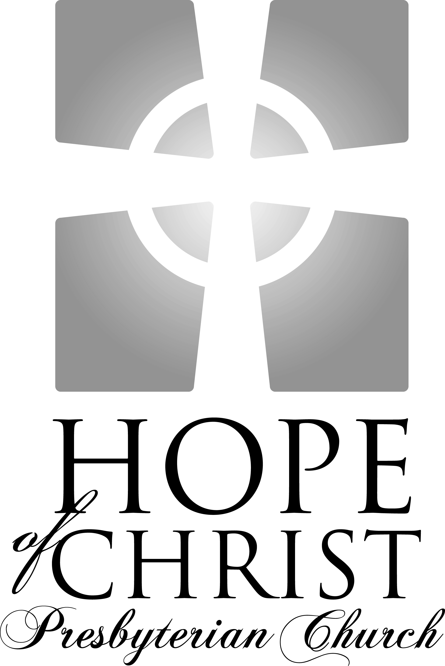

Knowing Jesus Christ Growing in grace
Going into the world with hope

"For to this end we toil and strive, because we have our hope set on the living God, who is the Savior of all people."
I Timothy 4.10

Sunday Service Times:
Adult & Children’s Sunday School: 9:15 – 10:05am
Worship Service: 10:30 – 11:45am

Song of Gathering March 1, 2009

Come Ye Sinners
Words by Joseph Hart, 1759, Music by Matthew S. Smith., 2000

Come, ye sinners, poor and wretched, weak and wounded, sick and sore;
Jesus, ready, stands to save you, full of pity, joined with power.
He is able, He is able; He is willing; doubt no more.

Come ye needy, come, and welcome, God’s free bounty glorify;
True belief and true repentance, every grace that brings you nigh.
Without money, without money come to Jesus Christ and buy.

Come, ye weary, heavy laden, bruised and broken by the fall;
If you tarry ’til you’re better, you will never come at all.
Not the righteous, not the righteous; Sinners Jesus came to call.

Lo! The Incarnate God, ascended; pleads the merit of His blood.
Venture on Him; venture wholly, let no other trust intrude.
None but Jesus, none but Jesus, can do helpless sinners good.

Welcome and Announcements

Meditation Zephaniah 3.14-17

Sing aloud, O daughter of Zion; shout, O Israel! Rejoice and exult with all your heart,O daughter of Jerusalem! The Lord has taken away the judgments against you; he has cleared away your enemies. The King of Israel, the Lord, is in your midst; you shall never again fear evil. On that day it shall be said to Jerusalem: “Fear not, O Zion; let not your hands grow weak. The Lord your God is in your midst, a mighty one who will save; he will rejoice over you with gladness; he will quiet you by his love; he will exult over you with loud singing.

Call to Worship Psalm 95.1-7a

Leader: Oh come, let us sing to the Lord; let us make a joyful noise to the rock of our salvation! Let us come into his presence with thanksgiving; let us make a joyful noise to him with songs of praise!

People: For the Lord is a great God, and a great King above all gods. In his hand are the depths of the earth; the heights of the mountains are his also.

Leader: The sea is his, for he made it, and his hands formed the dry land. Oh come, let us worship and bow down; let us kneel before the Lord, our Maker!

People: For he is our God, and we are the people of his pasture, and the sheep of his hand.

Songs of Praise

Here I Am To Worship
Words and Music by Tim Hughes, 2002

Light of the World You stepped down into darkness,
Opened my eyes, let me see
Beauty that made this heart adore you
Hope of a life spent with you

(Chorus)
Here I am to Worship, Here I am to bow down
Here I am to say that you’re my God
You’re altogether lovely, altogether worthy
Altogether wonderful to me

King of all days, oh so highly exalted
Glorious in heaven above
Humbly you came to earth you created
All for love’s sake become poor.

(Bridge x2)
I’ll never know how much it cost
To see my sin upon that cross

Be Thou My Vision
Words: Ancient Irish Hymn, Music: Traditional Irish Melody
Be Thou my vision, O Lord of my heart;
Naught be all else to me, save that Thou art
Thou my best thought, by day or by night,
Waking or sleeping, Thy presence my light.
Be Thou my wisdom, and Thou my true Word;
I ever with Thee and Thou with me, Lord;
Thou my great Father, and I Thy true son;
Thou in me dwelling, and I with Thee one.
Riches I heed not, nor man's empty praise,
Thou mine inheritance, now and always:
Thou and Thou only, first in my heart,
High king of heaven, my treasure Thou art.
High king of heaven, my victory won,
May I reach heaven's joys, O bright heaven's sun!
Heart of my own heart, whatever befall,
Still be my vision, O Ruler of All.
Responsive Reading Hebrews 10.23-31 Page
Prayer of Adoration and Confession

Assurance of Pardoning Grace Hebrews 10.18-22
Where there is forgiveness of these, there is no longer any offering for sin. Therefore, brothers, since we have confidence to enter the holy places by the blood of Jesus, by the new and living way that he opened for us through the curtain, that is, through his flesh, and since we have a great priest over the house of God, let us draw near with a true heart in full assurance of faith, with our hearts sprinkled clean from an evil conscience and our bodies washed with pure water.
Song of Assurance

Before the Throne of God Above
Words by Charitie L. Bancroft (1841-1892), Music by Vikki Cook

Before the throne of God above I have a strong and perfect plea.
A great high Priest whose Name is Love who ever lives and pleads for me.
My name is graven on His hands, my name is written on His heart.
I know that while in Heaven He stands no tongue can bid me thence depart.

When Satan tempts me to despair and tells me of the guilt within,
Upward I look and see Him there who made an end of all my sin.
Because the sinless Savior died my sinful soul is counted free.
For God the just is satisfied to look on Him and pardon me.

Behold Him there the risen Lamb, my perfect spotless righteousness,
The great unchangeable I AM, King of glory and of grace,
One with Himself I cannot die. my soul is purchased by His blood,
My life is hid with Christ on high, with Christ, my Savior and my God!

Giving of God’s Tithes and Our Offerings

Song of Thanksgiving

Wonderful Cross
Words and Music by Chris Tomlin

When I survey the wondrous cross
On which the prince of glory died,
My richest gain I count but loss,
And pour contempt on all my pride.

See from his head, His hands, His feet,
Sorrow and love flow mingled down.
Did e’er such love and sorrow meet,
Or thorns compose so rich a crown?

(Chorus)
O the wonderful cross, O the wonderful cross
Bids me come and die and find that I may truly live.
O the wonderful cross, O the wonderful cross
All who gather here by grace draw near and bless your name.

Were the whole realm of nature mine,
That were an offering far to small.
Love so amazing so divine,
Demands my soul, my life, my all.

Chorus

Were the whole realm of nature mine,
That were an offering far to small.
Love so amazing so divine,
Demands my soul, my life, my all.

Prayer for the Kingdom

Sermon Pastor Leonard Bailey
Acts 23.12-24.27 Page

The Alarming and Inconvenient Gospel

A Thwarted Conspiracy; 23.12-35

A Typical Trial; 24.1-21

An Uncomfortable Reality; 24.22-27

Song of Response

How Sweet and Awful Is the Place
Public Domain. Words: Isaac Watts. Music: ancient Irish tune.

How sweet and awful is the place
With Christ within the doors,
While everlasting love displays
The choicest of her stores.

While all our hearts and all our songs
Join to admire the feast,
Each of us cry, with thankful tongues,
“Lord, why was I a guest?”

“Why was I made to hear Thy voice,
And enter while there’s room,
When thousands make a wretched choice,
And rather starve than come?”

’Twas the same love that spread the feast
That sweetly drew us in;
Else we had still refused to taste,
And perished in our sin.

How sweet and awful is the place
With Christ within the doors,
While everlasting love displays
The choicest of her stores.

Benediction
Calendar for this Week:

Today 9:15am Sunday School

10:05am Fellowship & Refreshments

10:30am Worship Service

6:00pm Autumn Ridge Care Group at the Bailey’s home
(Leonard Bailey, 540-645-2880 or Don Davis, 540-720-2035)

Monday 7:00pm Edinburg Care Group dinner at the Jany’s home
(Paul Jany, 540-891-1118)

7:30pm Stafford Lakes Care Group at the Murphy’s home
(James Murphy, 540-752-6118)

Tuesday 7:00pm Women’s Discipleship. Meets every other Tuesday. Read
Chapter 9 of By Design. (Amy Bailey, 540-720-40189.)

Wednesday 7:00pm Aquia Harbor Care Group at the Leino’s home
(Rich Leino, 540-446-5918)

Thursday 7:00pm Praise team practice at the Griffin’s home.(Pete, 540-286-1821)

Upcoming Events:

4th Sunday Communion Sunday followed by a potluck lunch at H.H. Poole. Please
of Month bring food to share. Drinks provided.

March 14-15 New Life in Christ Missions Weekend. Our Pastor Leonard Bailey
will be speaking at the banquet Saturday evening and the Sunday
evening service. More information on Welcome Table.

March 28 Men’s Discipleship breakfast at 7:30am Jimmy the Greek Restaurant.
Read Part 3 of God-Made Man.(Leonard Bailey, 540-645-2880)
Nursery Ministry: Katie Murphy, 540-752-6118

March 1 Sunday School: J. Jany/K. Hamill/A. DiDomenico **Be there by 9:00 am
Worship: A. Bailey/G. Didomenico/M. Turner **Be there by 10:15 am

March 8 Sunday School: J. Jany/Maroneys
Worship: P. Griffin/E. Garner/M. Davis
Refreshment Ministry: Stephanie Turner 703-391-7241

March 1 Stephanie Turner
March 8 Larry & Peggy VanHooser
Birthdays this week:

March 1 Luke Davis
March 3 Stephanie Turner
Contact Information:

Pastor Leonard Bailey Home: 540-720-4089
Leonard@HopeofChrist.net Mobile: 540-645-2880
http://www.HopeOfChrist.net
website has links to Sermon Podcast & Google Group

